


SHRI BHAGUBHAI MAFATLAL POLYTECHNIC
AND COLLEGE OF ENGINEERING

INFORMATION TECHNOLOGY DEPARTMENT

NEWS AGGREGATOR

Project By:
Bhavika Dhakate (57498230001)-T001
Mahek Sanghavi (57498230003)-T003
Avishi Wadher (57498230016)-T016

INTRODUCTION
A News Aggregator is an application or website that collects news articles from multiple sources and presents them in one centralized platform.
A modern and responsive web application built using React.js.
Aggregates real-time news articles from trusted sources such as BBC, CNN, Reuters, The New York Times, and more.
Provides a centralized platform where users can explore news across multiple categories like Business, Technology, Health, Sports, and Entertainment.
Features an intuitive user interface with category filters, search functionality, and bookmarks for personalized news access.

PROBLEM STATEMENT
In today’s digital world, people rely on multiple online platforms like BBC, CNN, and Reuters to stay updated with the latest news. However, constantly switching between different websites is time-consuming and inconvenient. Each platform provides news in its own format, making it difficult for users to access, filter, and personalize content efficiently.
Moreover, most news websites lack features such as category-based filtering, real-time search, bookmarking, and personalization, which are essential for improving user experience. Accessibility is also a challenge, as not all sites provide smooth, responsive designs optimized for both desktop and mobile devices.
To overcome these issues, there is a need for a centralized, modern news aggregator that collects articles from trusted sources, organizes them into categories, and presents them through a single responsive platform. With features like search, filters, and bookmarking, such a system ensures quick access, convenience, and a personalized reading experience for users.

FEATURES
Centralized News Feed – Collects news articles from multiple trusted sources in one platform.
Category-based Filtering – Browse news easily by topics like Business, Sports, Technology, Health, etc.
Real-time Search – Search and access articles instantly with keyword-based results.
Bookmarking – Save important articles for later reading using local storage.
Responsive Design – Ensures smooth user experience across desktops, tablets, and mobiles.
User-friendly UI – Simple navigation with clean layouts for better accessibility.
Loading & Error Handling – Displays proper messages for API errors or slow connections.

TECHNOLOGIES USED

Frontend Framework – React.js
Styling – CSS (App.css, responsive design)
API Integration – NewsAPI (to fetch real-time news)
State Management – React Hooks (useState, useEffect)
Local Storage – For saving bookmarks and search history
Build & Deployment – Node.js, npm/yarn, and hosting platforms (Netlify/Vercel)

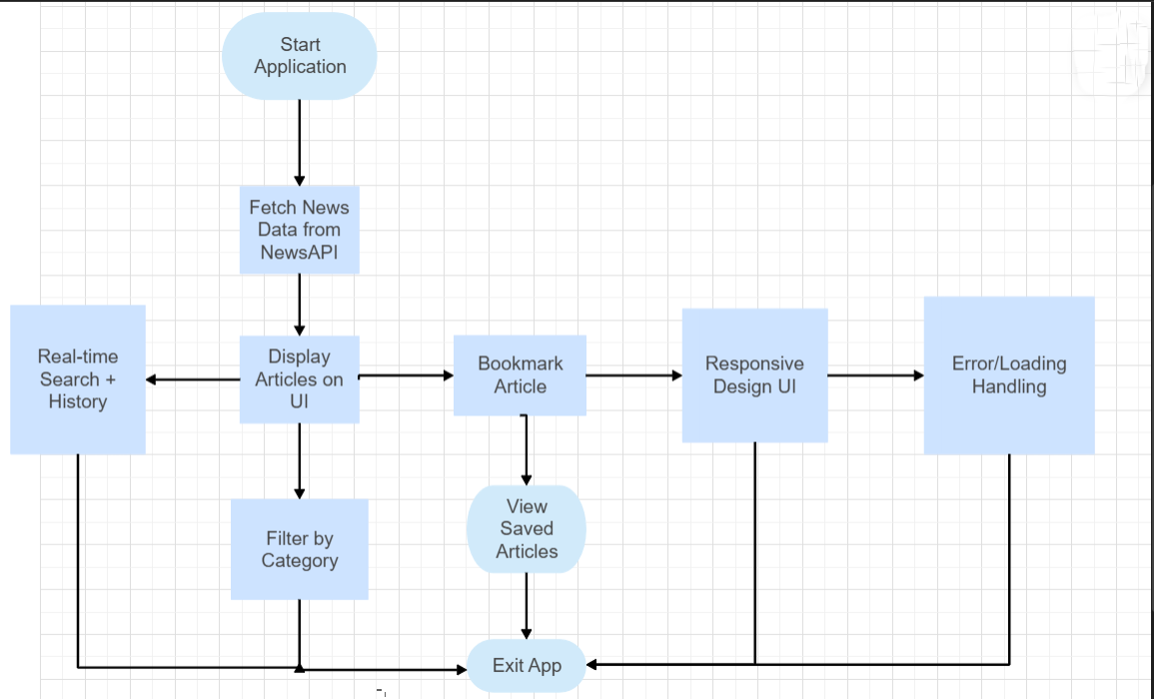
FLOWCHART

USE CASE DIAGRAM
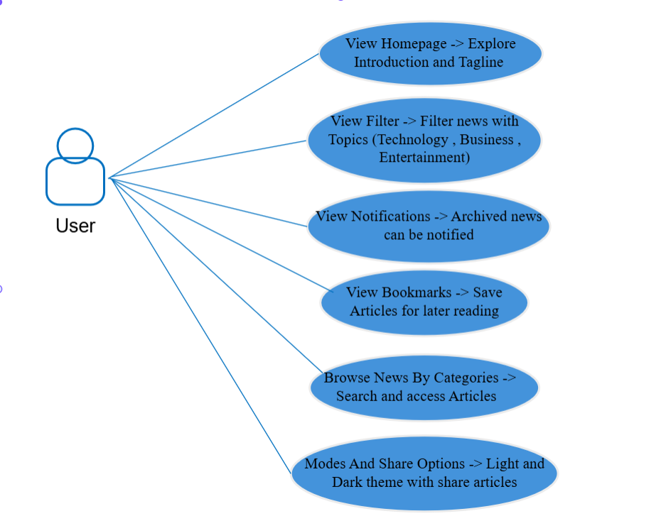

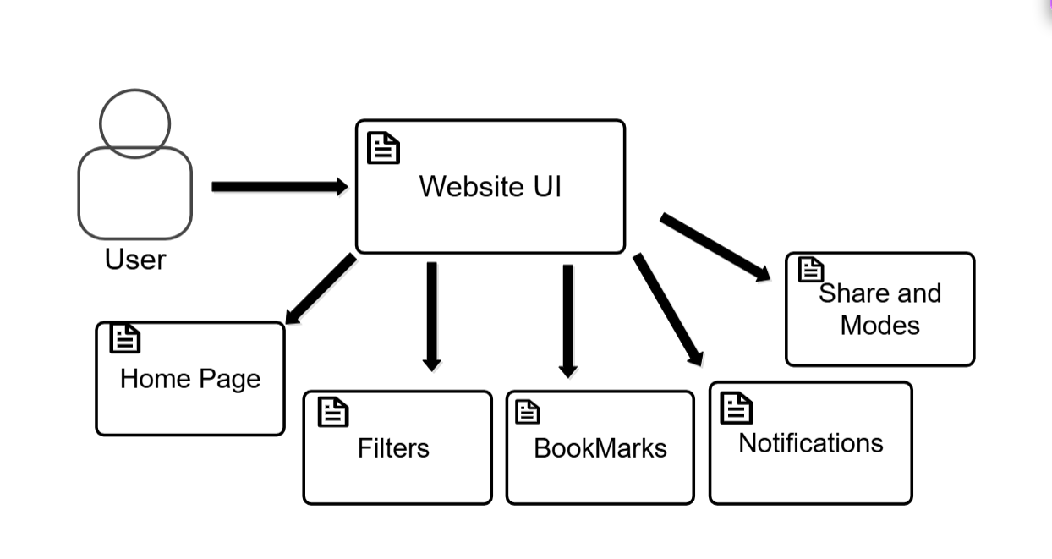
COMPONENT DIAGRAM

SCREENSHOTS
Homepage :
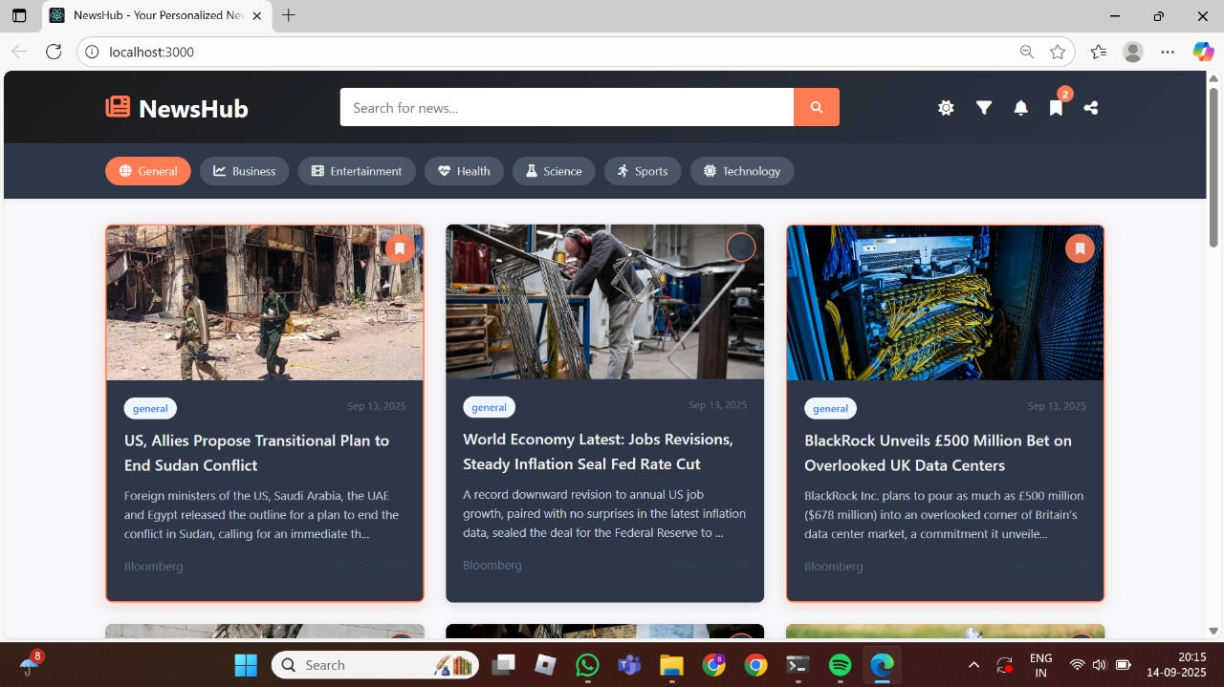
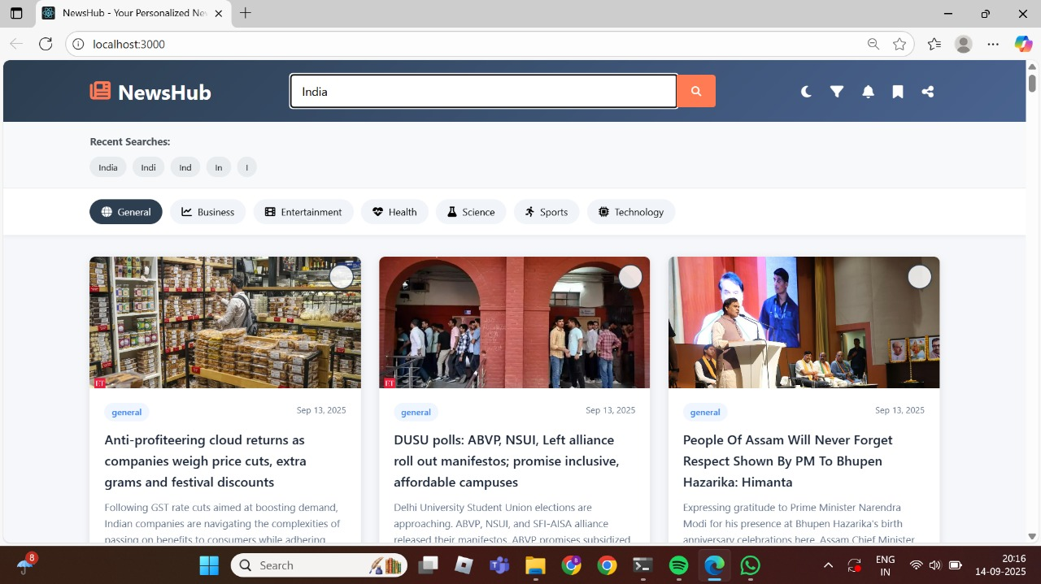
Search News Real Time :

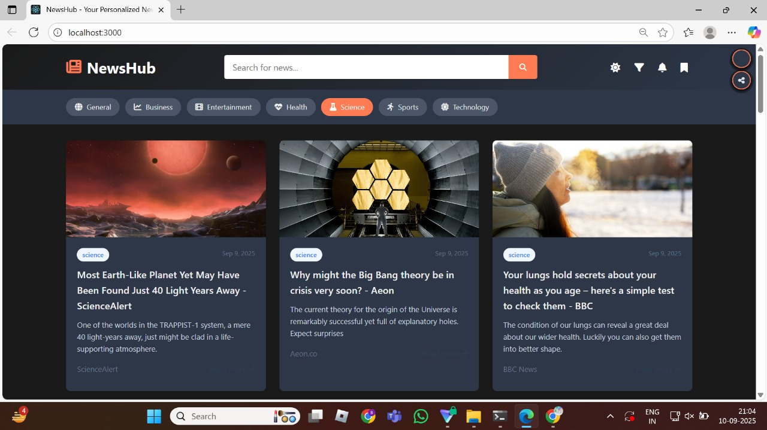
Filtering Categories :
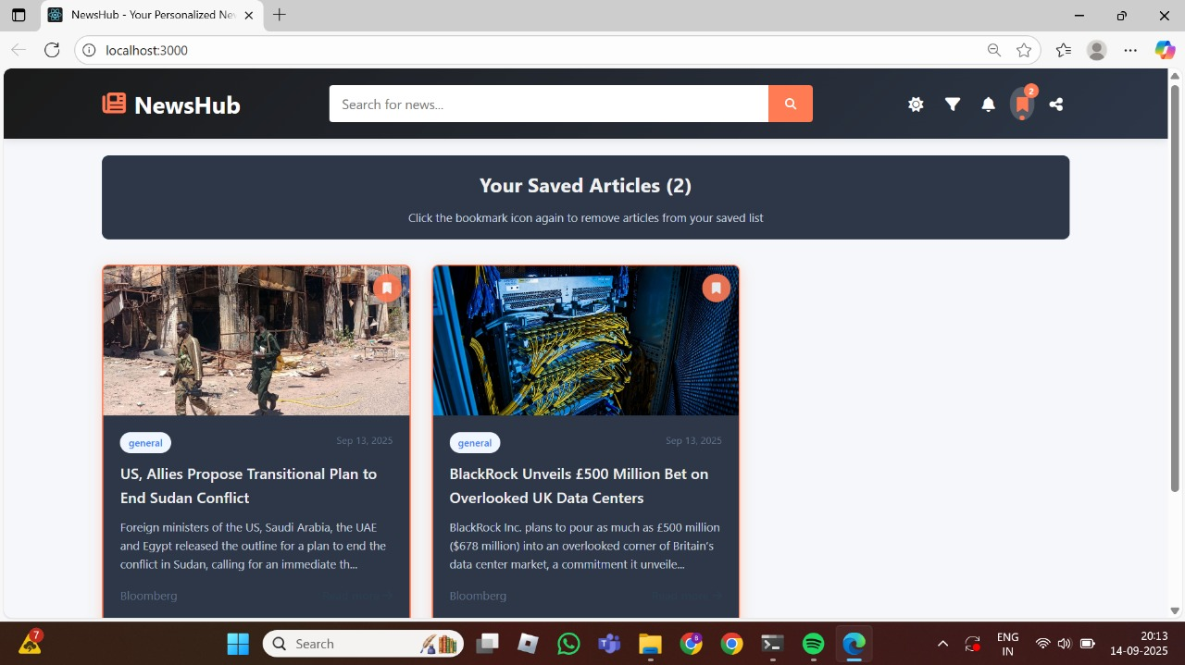
BookMarks :
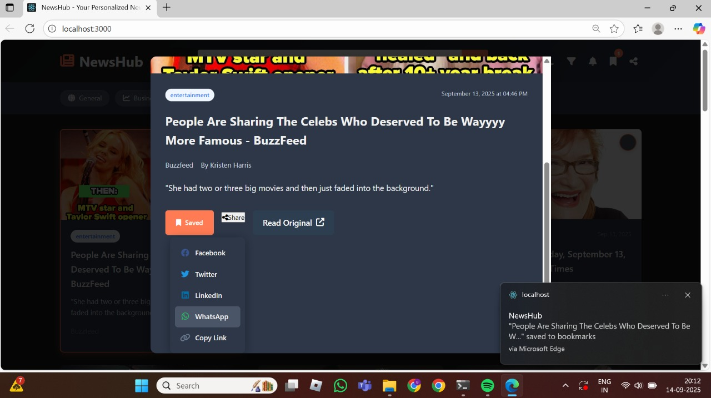
Saved :
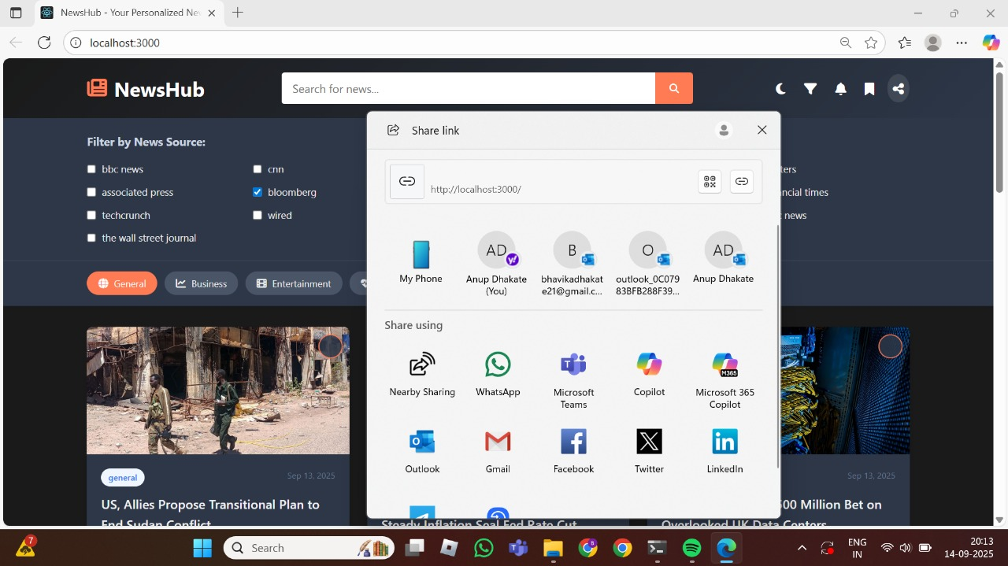
Share :

FUTURE SCOPE
AI-powered Recommendations – Personalized news feed based on user interests and reading history.
Multi-language Support– Access news in different regional and international languages.
Offline Reading – Save articles for reading without an internet connection.
Push Notifications – Real-time alerts for breaking news and trending topics.
User Accounts – Login system for customized preferences and cross-device sync.

CONCLUSION
NewsHub enhances news accessibility through filters, bookmarks, and personalization features.
It Offers a responsive UI ensuring smooth user experience across devices.
Some of the Future Enhancements:
- AI-based personalized news recommendations
- Multi-language news accessibility
- Offline reading support
NewsHub establishes a scalable, modern, and user-friendly news aggregator.

